
2023 Pogues Run Macroinvertebrate Sampling Summary
Macroinvertebrate sampling on Pogues Run consists of three sites, each sampled once per year. Metrics, such as HBI and Shannon-Weaver Diversity are monitored and compared from year to year to track any possible trends in the macroinvertebrate community. These trends can help identify possible water quality issues. Sites are selected both upstream and downstream of combined sewer overflows to compare results. Sites with green markers are upstream, and those with purple are downstream.
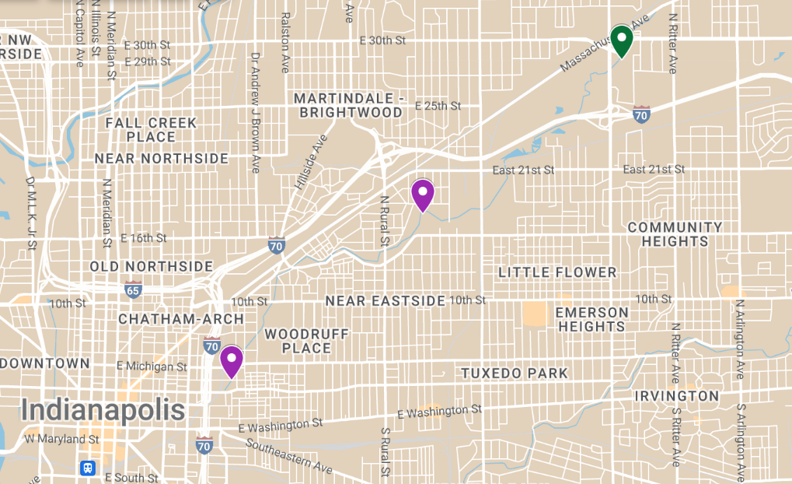

SITE | COORDINATES
Pogues Run @ 30th St | 39.48638, -86.04819
Pogues Run @ Brookside Park | 39.786733, -86.121072
Pogues Run @ Vermont St | 39.46334, -86.08362

Note: Vermont site not sampled in 2023

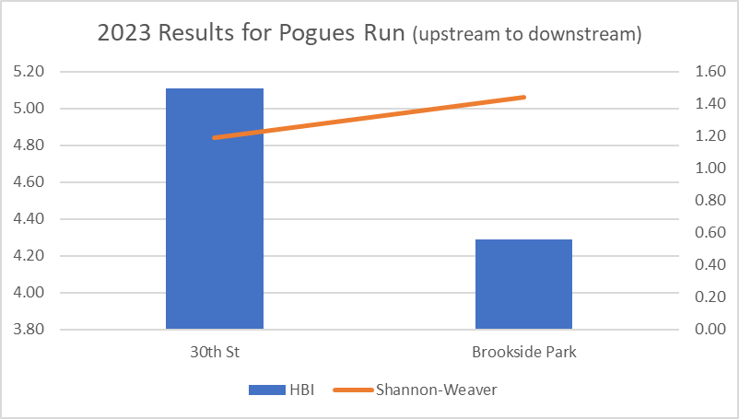

Note: Good water quality is indicated by low HBI and high Shannon-Weaver values.

Hilsenhoff Biodiversity Index (HBI)
HBI is one parameter that is used to determine the overall health of each stream sampled. This index is calculated by using the tolerance levels of various aquatic macroinvertebrates to estimate the overall water quality of the stream. The lower the HBI, the higher the water quality (less pollutants, etc.). HBI totals for 2023 were generally lower compared to previous years, however, only two of the sites could be sampled.
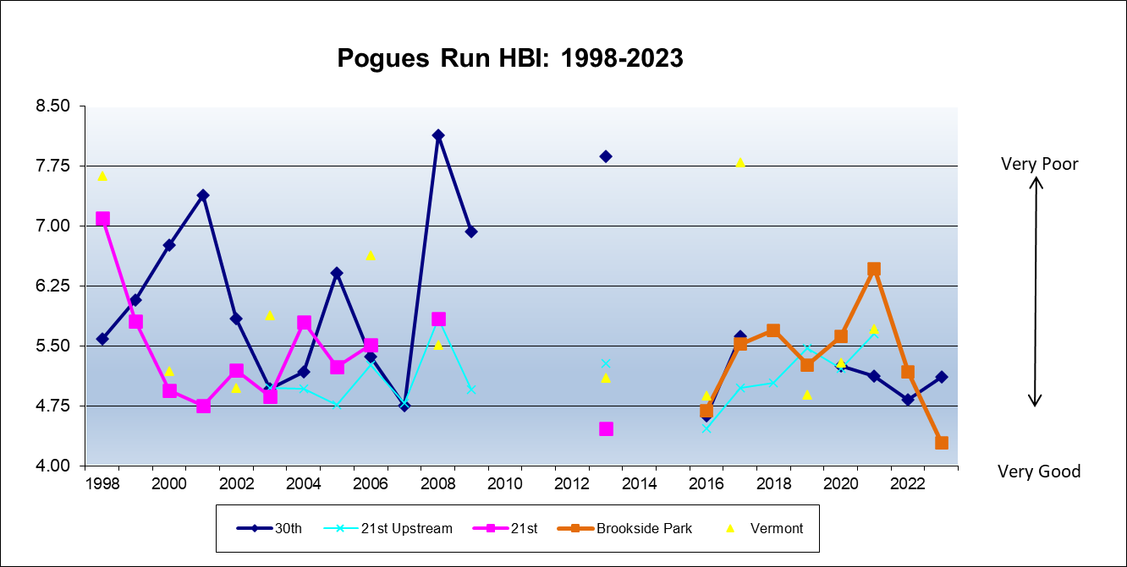

Note: breaks in line indicate years where the site was not sampled due to circumstances such as weather, construction, habitat degradation, etc.

Shannon-Weaver Mean Diversity
This parameter is designed to gauge the diversity of each site by using both the total number of individuals and the number of species found. The higher the number, the more diverse the stream’s macroinvertebrate community, indicating healthier habitat and water quality. Diversity numbers for 2023 were equal or lower than previous years indicating possible negative changes to water quality or habitat. However, upstream sites had higher levels than downstream sites, which is expected due to the number of combined sewers in this area.
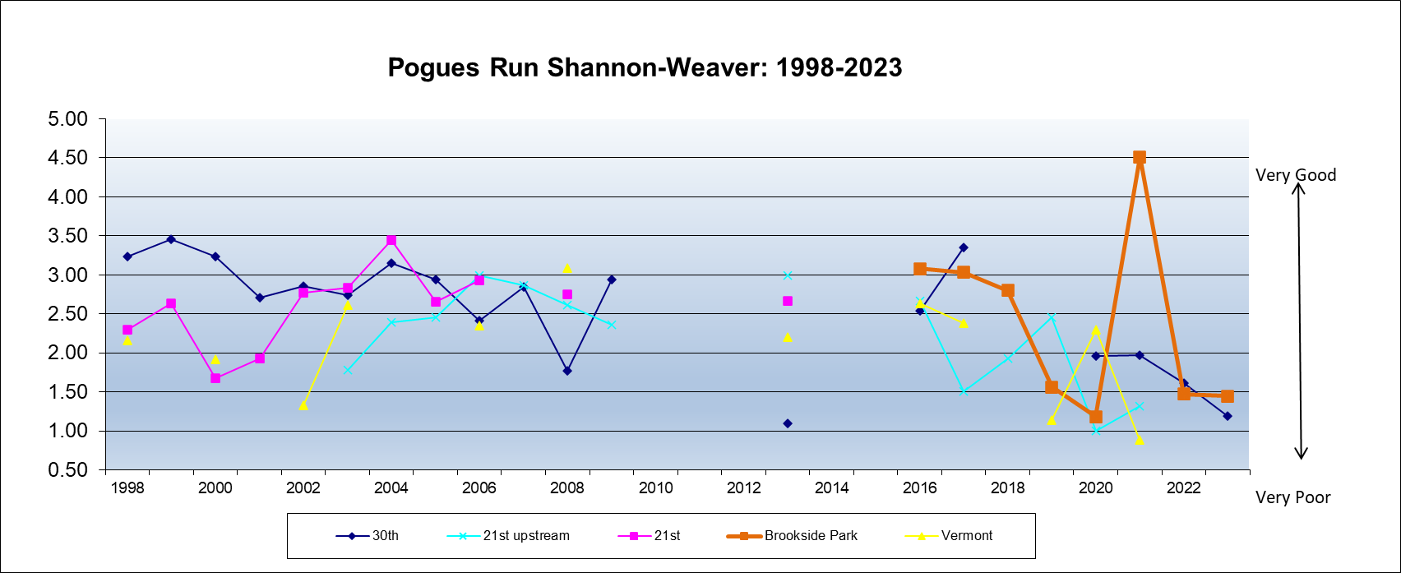

Note: breaks in line indicate years where the site was not sampled due to circumstances such as weather, construction, habitat degradation, etc.

