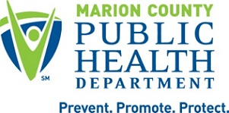
2023 Pogues Run Sampling Summary

The Pogues Run sampling route is located within the Lower White River watershed and includes sites along White River and Pogues Run. The ambient sampling route includes 8 sites that are sampled for bacteria 5 times per month year-round and 3 times a year for chemicals. Macroinvertebrate sampling occurs once a year at 3 sites. Sampling results for 2023 were assessed by looking at trends and applicable surface water quality standards. These water quality standards are based on the Indiana Administrative Code (327 IAC 2-1-6) and parameters are considered “out of range” if the detected level exceeds that determined by the IAC.

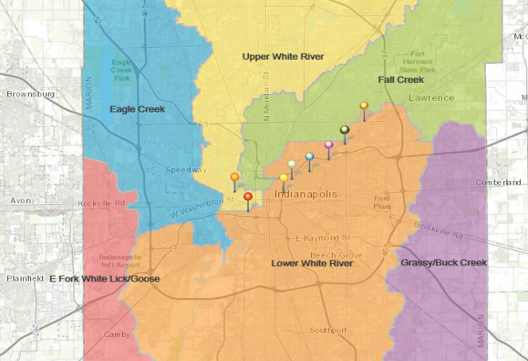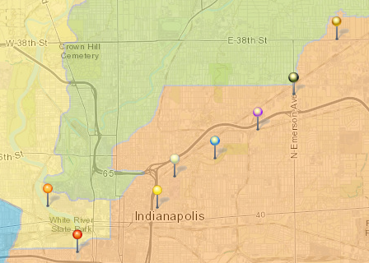

SITE NAME | COORDINATES
White River @ Kentucky Ave | 39.756823, -86.173353
White River @ New York St | 39.771778, -86.186278
Pogues Run @ New York St | 39.771, -86.141
Pogues Run @ 10th St | 39.780194, -86.133833
Pogues Run @ Rural St | 39.787194, -86.116444
Pogues Run @ 21st St | 39.79625, -86.098639
Pogues Run @ Emerson Ave | 39.808667, -86.082083
Pogues Run @ 38th St | 39.825389, -86.065667

Ambient E. coli Sampling
In 2023, the Pogues Run was sampled 59 times and included 330 total E. coli samples (occasionally samples are unable to be collected due to road closures, bridge construction, frozen stream, etc.). Results are then compared to the recreational surface water standard of 235 MPN/100 ml. E.coli is an indicator of raw sewage and most of the sites on this route are located within the Indianapolis’ Combined Sewer Area. Combined sewers dump untreated sewage into the creeks during rain events since the sewer lines and storm lines are shared. E.coli bacteria are expected to be higher as sites go downstream due to the 24 combined sewer outfalls located along Pogues Run.
SITE | % EXCEED STD  (2023)
38th | 64.1
Emerson | 82.8
21st | 31*
Rural | 52.5
10th | 63.8
New York | 60.3

*Note about 21st St site: this site is located just downstream of the Pogues Run Art and Nature Park, which is a constructed wetland designed to improve water quality by allowing pollutants to settle out naturally. Due to this, E.coli levels are consistently low at this sampling location.

Ambient Chemical Sampling
Chemical samples are completed three times a year, in March, July, and November at all eight sites. During 2023, Ammonia was the only chemical detected above IAC standards. Sources of Ammonia include sewage influence, animal waste and fertilizer use.
Table 2: Number and percentage of samples from Pogues Run that were above IAC standards.
Surface Water Parameter | Occurrences of Out of Range Values, 2023 | % of Samples Out of Range, 2023
Chloride | 0 | 0
Ammonia | 8 | 33
VOCs | 0 | 0
Heavy Metals | 0 | 0

